CST1510 Programming for data communication and networks – CW2
Title: Smart Vending Machine for Digital Goods
Credentials
- Name: Zainab Arslan Dar
- Student Number: M00987182

1. Project Overview
- I started with the main text-based program, and named it load_inventory_final, I created a basic command-line interface where users can choose from menu, to view products, add products to cart, view cart, checkout and exit. I used python structures including dictionaries, lists, strings, different loops, functions, file handling, user input/output. Then, I refactored the same code file with Object Oriented Programming structure by creating 3 different classes Product, Cart and VendingMachine, and dividing the functions, created previously, respectively. Next, I created a client and a server python file, in my server file I imported the load_inventory_final file, so that the server fetches data from the it (the functions), and connects it to the inventory.txt and transaction.txt file, and once the user purchases products using the client file, it automatically updates both the transaction and inventory file. Using sqlite3, I created a python file “shopping_system_SQL” which creates a database “shop.db” using sqlite3, and in that creates two tables “products” and “transactions” which get updated when the user purchases the product. Then I created a GUI, which displays the product inventory data, and pictures/logos along with products for an more user-friendly interface,I created add to cart buttons for the user to add products into their cart, I created a cart summary which stores the product name, quantity and calculates the total of all the products the user adds to the cart, and then a proceed to checkout button, which confirms if the user wants to checkout and if the user clicks yes, it shows a checkout successful message. I integrated the GUI with database shop.db by using sql queries so that the once the user purchases/makes a transaction, the tables in the database get updates and the data get stored. Then I created a real-time stock distribution graph using matlplot library and matplotlib.animation.FuncAnimation tool, which gets updates once the shop.db database gets updated, and shows the stocks trend of products based on the database tables in shop.db.

- [List the list of class of files used]
  - Client (client.py)
  - Server (server.py)
  - SQLite3 (shopping_system_SQL)
  - DB (shop.db)
  - GUI (GUI.py)
  - Txt file (transaction.txt, inventory.txt)
  - Py file (load_inventory_old.py)
  - Refactored file with OOP (load_inventory_final.py)
  - Matplot (matplot_graph.py)

2. UML Diagram
You can create the UML diagram using tools like app.diagrams.net. Below is an example representation.
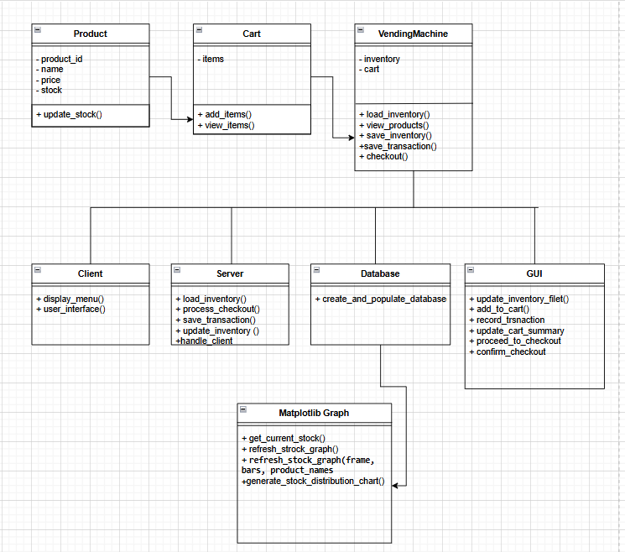

Description of File Functionalities:

- load_inventory_final.py: main file which includes all the functions (add_to_cart, view_products, save_inventory, save_transaction, checkout, etc) with OOP implemented classes named Product, Cart and VendingMachine.
- shopping_system_SQL.py: Asks the user the menu to purchase product, creates a database named, shop.db, creates a table named “products” and another table named “transactions” inside shop.db to store the respective details and update them as the user purchases the products.
- client.py: Implements a socket-based interface allowing the user to interact with a server to manage a shopping experience, including viewing products, adding items to a cart, viewing the cart, and checking out.
- server.py: the server file is connected to load_inventory_final.py file to facilitate client-server communication for a vending machine system, handling client requests like viewing products, adding items to the cart, viewing the cart, and completing transactions.
- GUI.py: Creates an interactive shopping experience for a vending machine, allowing users to view available products with pictures, add them to a cart, and proceed to checkout with real-time updates on inventory and transactions.
- matplot_graph.py: I implemented a real-time stock distribution graph that updates dynamically using data from a SQLite database. I created functions to retrieve product stock levels from the database, and then used matplotlib with FuncAnimation to display and continuously update the graph every second. This allows me to visualize inventory changes in real time.
- inventory.txt: Inventory product data file.
- transaction.txt: file to log the transactions made ny the users using client and GUI.

3. Implementation Plan
3.1 The project was implemented in the following stages:
- Text-Based Files:
  - I created a text file inventory.txt with appropriate headings (id,product_name,price,stock) and 10 product items’ data under them.
  - I created a load_inventory_old.py file which implemented all the functions (functions (add_to_cart, view_products, save_inventory, save_transaction, checkout) and displayed a menu for the user to purchase products.
  - Then I created a transaction.txt file, which stores the transaction records every time the user purchases products in the GUI, load_inventory_final, client and matplot_graph file.

- Object-Oriented Refactoring:
  - I refactored my load_inventory_old.py code to OOP structure and segregated the functions into 3 different classes (Product, Cart and VendingMachine) into a new file load_inventory_final.py file.
  - I imported the same load_inventory_final.py file to server file, and same OOP code to the SQL file “shopping_system_SQL”.
- Client-Server Model:
  - I have implemented a basic shopping system that interacts with my SQLite database “shop.db” created in shopping_system_SQL file.The server processes client requests like viewing products, adding items to the cart, checking the cart, and completing the checkout. Upon checkout, transaction details are saved in the database table “transactions”, and the inventory is updated to reflect the purchases in “products” table. The server uses socket to interact with client , SQLite queries manage both the inventory and transaction data.
  - I created a client that connects to the server, allowing users to view products, add items to their cart, check their cart, and checkout. It sends user choices to the server and displays the server's responses.
- Database Integration:
  - In this code, I created a database with two tables: "products" to store product details and "transactions" to log purchases using sqlite3 for better record handling.
- GUI Implementation:
- I developed a Tkinter-based graphical user interface (GUI) that allows users to browse products, manage their cart, and complete transactions. The interface includes product details with images, stock management, recording transactions in trsansaction.txt file , and checkout functionality to process purchases and update stock in the inventory.txt file.
4. Running Instructions
4.1 Prerequisites:
- Python 3.11 and Pycharm 2024.2.3 were installed on my system.
- Required libraries: socket, sqlite3, tkinter, pyside6, matlplotlib (install by going to pycharm setting, and selecting Python Interpreter and click plus (+) icon and search the respective package and install package.)
4.2 Steps to Run:
- Open the load_inventory_final.py file, this is the OOP structured file, asks the user to select the options from the menu (add_to_cart, view_products, save_inventory, save_transaction, checkout ) to purchase the products, and also updates inventory stock and transactions made by the user.
- Open the inventory.txt file, it includes the product inventory data, which gets updated once user purchases the product.
- Open the transaction.txt file, this file stores the transactions made by the user.
- Run the shopping_system_SQL file, this file creates database “shop.db” and in that database creates two tables “products” and “transactions” . the products table will get updated, when the user purchases products using the client file and the transaction file will log the transactions made by the user.
- Run the server.py file first.
- Then run the client.py file.
- Run the GUI, add products to cart and proceed to checkout, the products table and transactions table will be updated in the shop.db database.
- Run the matplot_graph.py file to view the graph based on the shop.db database.

5.1 Learning Highlights:
Reflect on the skills and concepts you gained during the project:
- I gained a better understanding of concepts on Object-Oriented Programming (OOP) principles.
- I gained experience in using SQLite to store and manage product and transaction data.
- I learnt how to set up client-server interaction using Python's socket library for product retrieval and transaction processing.
- I learnt how to integrate different files, by either importing files or creating suitable functions.
- I built a graphical user interface (GUI) for the vending machine using Tkinter, learning how to create windows, buttons, and labels to allow users to view products, manage their cart, and complete transactions.
5.2 Challenges and Solutions:
- Challenge: Ensuring data consistency and integrity was difficult, especially when interacting with the inventory and processing orders. I had to make sure that the product stock was correctly updated when items were added to the cart or during checkout.
- Solution: To solve this, I used SQLite to manage product data, ensuring the inventory was updated whenever a product was added to the cart or purchased. I implemented stock checks before adding items to the cart, and real-time updates occurred during checkout to maintain data consistency.
- Challenge: Ensuring reliable socket communication was difficult, especially when connection loss or timeouts disrupted the communication, particularly during transactions where the client expected quick responses.
- Solution: I handled socket timeouts on the client side by setting timeouts for socket operations. On the server side, I used exception handling to catch connection errors and ensured that the server properly acknowledged requests and sent responses in the correct format.
- Challenge: I faced challenges with loading and displaying product images in my GUI correctly, as incorrect file paths or missing images sometimes caused errors. Ensuring the images fit properly within the layout was also important.
- Solution: I used error handling with a try-except block to manage image loading issues. Additionally, I resized the images to a consistent size before displaying them, ensuring they fit in the GUI.
- Challenge: Ensuring inventory data remained accurate when users added products to the cart or made a purchase, keeping both the in-memory inventory and the database synchronized.
- Solution: I updated both the in-memory inventory list and the database whenever a product was added or purchased. The stock was checked and updated in real time, ensuring consistency between the cart and the database.
- Challenge: The main challenge was updating the stock distribution chart in real-time to reflect changes in inventory as products were purchased or added, while ensuring smooth animation and preventing performance issues.
- Solution: I implemented “FuncAnimation” from matplotlib to refresh the chart every second with updated stock data from the database. The “refresh_stock_graph” function adjusts the bar heights to match the current stock, and I disabled caching to maintain smooth, up-to-date animation.
5.3 Potential Improvements:
- Better error handling - I could add more checks and validation to prevent crashes and ensure data integrity.
- I could improve database queries and indexing for faster inventory updates.
- Handle Multiple Connections: I could use threading or to handle more users at once and improve performance.
- Error Handling: I could add better error handling to catch database connection issues or SQL errors.
- I could add checks to ensure valid data before inserting into the database .
- I could improve the product display by adding features that allow users to filter or search products based on categories, price range, or availability. This would make it easier for users to find specific items they’re interested in and enhance the overall user experience.
6. Technical Specifications
- Programming Language: Python 3.x
- Libraries Used:
  - socket: For managing communication between client and server.
  - os: provides functions to interact with the operating system, for example I used it to check if certain files, like "transaction.txt," already exist before writing to them. This ensured that I could properly handle file creation and prevent overwriting.
  - sqlite3: For database operations.
  - tkinter: For building the graphical user interface.
  - PIL (Pillow): Library used for image processing, including opening and displaying images.
  - ImageTk (from PIL): A part of the Pillow library that converts images into a format suitable for displaying in Tkinter widgets.
  - messagebox (from tkinter): Provides pop-up dialog boxes for displaying messages to the user (e.g., error messages, confirmations).
  - matplotlib.pyplot: A module used to create static, animated, and interactive visualizations, such as graphs and charts.
  - matplotlib.animation.FuncAnimation: For making animated graphs that update in real-time as the data changes.
- Platform Compatibility: Designed to run on any environment supporting Python 3.x.

References:

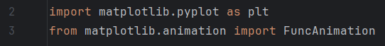
Researched on how to use matplotlib function to produce a well-organized graph, used w3schools.
https://www.w3schools.com/python/matplotlib_pyplot.asp

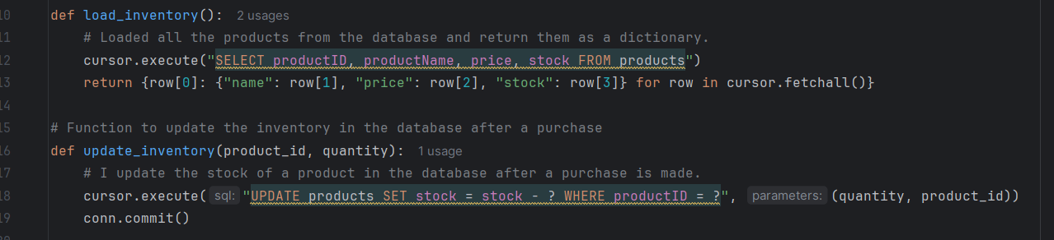
Implemented con.cursor, cursor.execute database functions using the sqlite3 tutorial.
https://docs.python.org/3/library/sqlite3.html

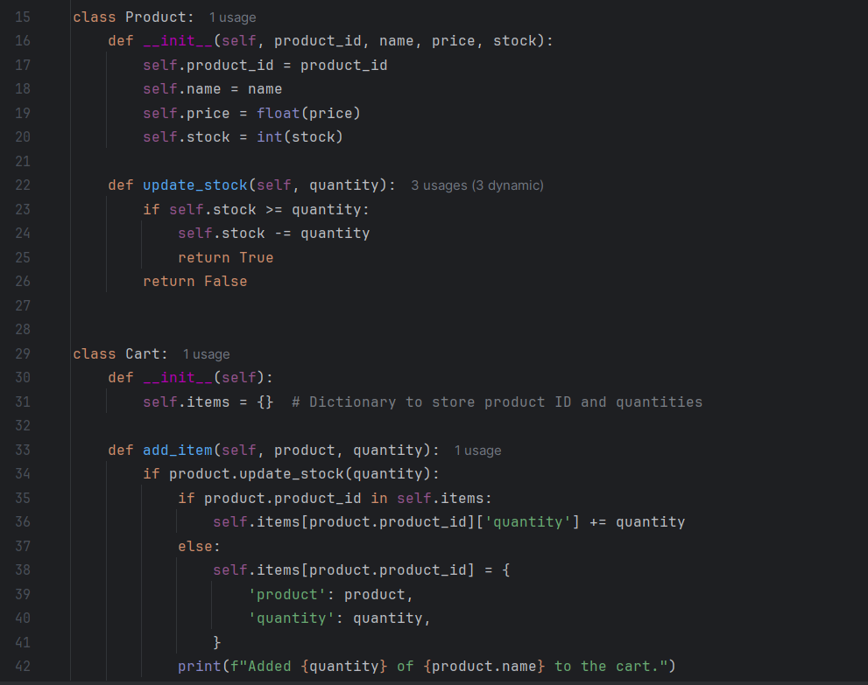
Refactored my code using OOP by learning concepts from mymdx Week 7 Lab material.
https://mdx.mrooms.net/course/view.php?id=41048

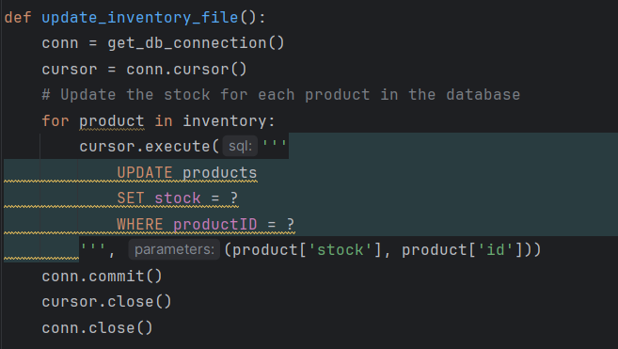
Used the same python docs tutorial to connect the database “shop.db” tables to GUI file. https://docs.python.org/3/library/sqlite3.html

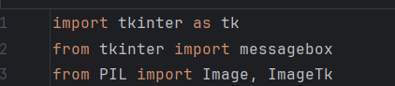
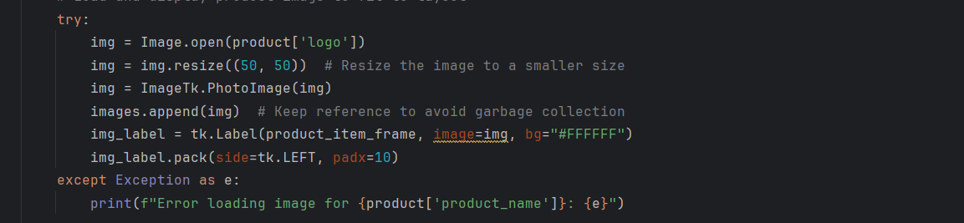
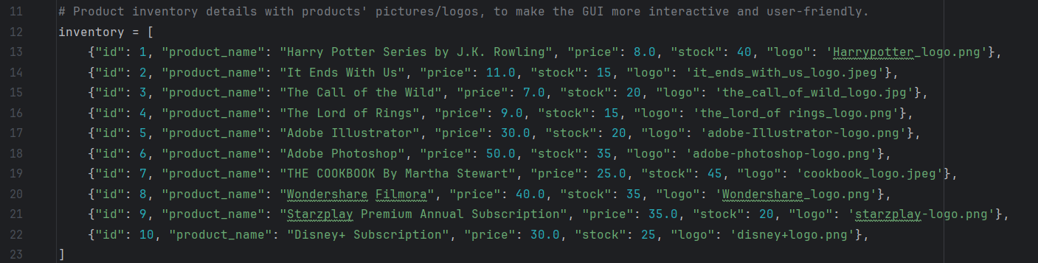
Added png, jpeg, jpg files to display logos next to the product names for more user-friendly GUI by using the geeksforgeeks tutorial.
https://www.geeksforgeeks.org/how-to-add-an-image-in-tkinter/
Overall, I used the resources uploaded in mymdx CST1510 Programming for Data Communications and Networks module material, and I also used the videos uploaded by the professor under week 8 and 9 as a guide to develop my load_inventory_old.py , load_inventory_final.py (OOP) and client, server files.

